1. Check the Http status code .

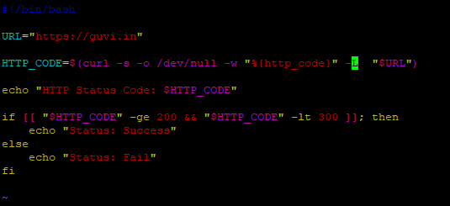

Output :

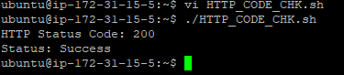

1. Replacing “give” with “learning” from 5th line . which contains word “welcome”.

